Roman Republic (510-46 BC)
- Roman Republic’s Government: Aristocratic Monarchy w/ Democratic element
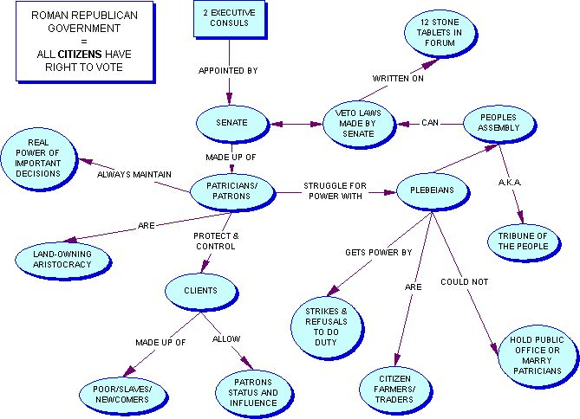
Monarchical | Aristocratic | Democratic
2 Consuls | Senate | Assembly of Tribes - Tribune
Basis of power: | Basis of power:. | Basis of power:
Limits on power: | Limits on power:  . | Limits on power:
- Problems of Republic: Social Class Tension
  - Patricians vs. Plebians – why? Three reasons…
#1 = MONEY & INFLUENCE
    - Patricians
      - Lived in _____________ where ______________ protected their property
      - Bought their way out of ______________________________________
      - Patrician status was __________________________
      - Held virtually …
    - Plebians
      - Generally lived …
      - When serving in army…
      - During war, their farms …
      - Return from war & had to borrow …

Problem #2: The Law of Debt
    - “Law of Debt”
      - If plebeians owned land, they generally needed to …
      - If they could not pay debt…
      - Creditor usually a __________________
      - Effect was to keep poor …
Problem #3: Unequal Division of Land
    - All land acquired through war belonged to …
      - But government in hands of ________________________
        - Patricians used public lands for their ____________________________
        - Allowed it to be used by other patricians =>

      - Patricians thought of public land …
Result of Class Tension? REVOLT!
  - In about 450 BC, Plebeians revolted =>
  - Patricians, seeing loss of their army….
  - Legal changes = _____________________ of ________________
    - Legal code adopted ….
    - Canceled all ___________ and released all ______________________ from slavery
    - Created new public office, the ______________________
      - ____________ appointed from Plebeian class
      - Given power to __________________ (over-rule) any patrician office holder who acted unjustly
      - Tribunes could not be _____________________
    - Put laws on bronze tablets near Forum (marketplace) so …
- Roman Citizenship
  - Rights of Citizens
 | Patricians | Plebians
Hold Office? (Y/N)
Vote? (Y / N)
Own property? (Y/N)
Social intermarriage allowed? (Y/N)
Enter into legal contracts? (Y/N)
  - Responsibilities of citizens (write them in here)

